Date: | Thursday, April 29, 2021 Rain or Shine
Entry Deadline: | Thursday, April 22, 2021
Times: | 8:30 – 9:30 Registration & Beverages
 | 9:00 Warm Up Shooting Opens
 | 9:45 Safety Briefing & Shooters Release to Course
10:00 Start Shooting
12:00 Lunch
 | 1:00 Raffle, Awards & Drawings
Place: | Seven Springs  777 Water Wheel Dr, Champion, PA  (814) 352-7777  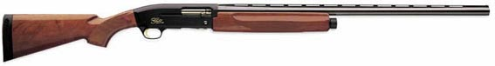
Event: | 100 Target Sporting Clay
Awards & Prizes: | Individual High Overall Man & Women, Team - High Score & Runner Up.  Raffle prizes, gun raffle, 50/50 tickets
Costs: | Individuals: $175 must be a member to register  Team: $600 for a 4-person team (registrant must be a paid member)  Entry Includes Electric Carts, 100 Clay Targets, Ammo, and Lunch

